Jewellery CAD Image Similarity Search
Documentation | System Architecture | Implementation Details

1. Project Overview
This project builds an image-based similarity search engine tailored for jewellery CAD designs. The system supports two CAD file formats:
- .3dm (MatrixGold)
- .jcd (Rhino 8 with DesignGold)
Each CAD file is rendered to four standardized views:
- Front
- Top
- Side
- Perspective
These views are screen-captured, automatically cropped to the CAD object area by an IBM RPA bot, then processed into high-dimensional embeddings using a pretrained vision model. The embeddings are indexed in FAISS for efficient similarity search.
The search API/UI allows users to upload an image and choose a view type (Front/Top/Side/Perspective), returning visually similar designs.

2. Key Objectives
- Automate CAD image extraction from .3dm and .jcd files.
- Automated cropping of CAD objects using RPA bot screen capture and crop tools.
- Generate view-wise image embeddings using a pretrained model.
- Index embeddings with FAISS using cosine similarity for robust retrieval.
- User search interface with selectable view types.

3. System Components
- RPA Automation for CAD Rendering and Image Cropping
- Preprocessing & Image Storage
- Embedding Generation with Vision Model
- FAISS Vector Indexing and Search
- Search UI / API

4. Core Concepts
Term | Meaning
CAD File | A jewellery design file (.3dm, .jcd)
View | Standard views: Front, Top, Side, Perspective
Embedding | High-dimensional numeric representation of an image
FAISS Index | A vector database storing embeddings for similarity search
Automated Cropping | RPA-bot driven image trimming for CAD area

5. High-Level Architecture

IBM RPA Bot To Generate CAD View Images

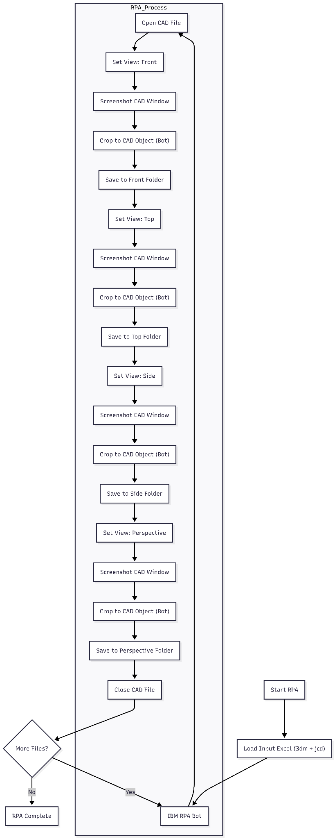

CAD Image Similarity Search System Architecture
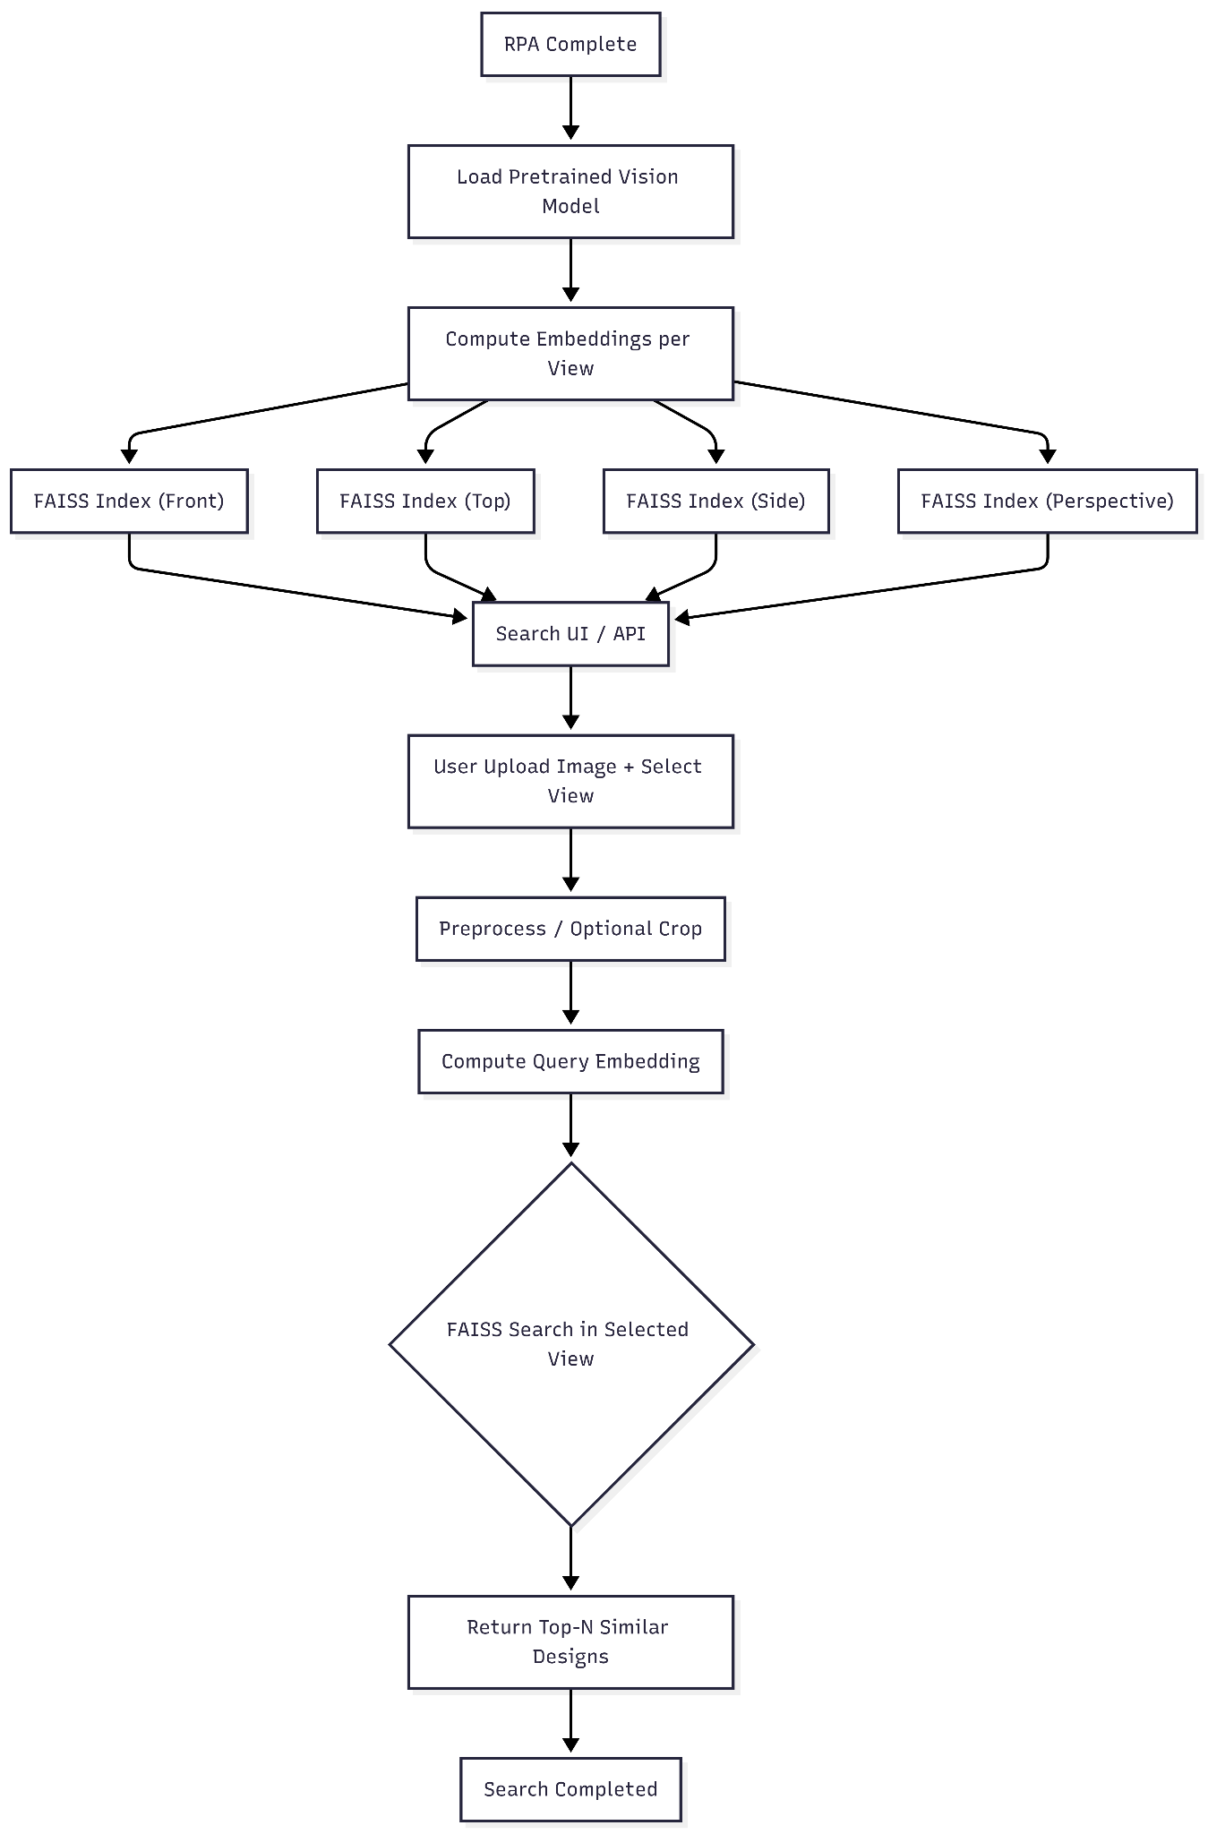

6. Detailed Workflow

6.1 Input Data Preparation
You maintain two Excel lists:
- Excel A: .3dm file paths and design codes
- Excel B: .jcd file paths and design codes
Each row contains:
- Absolute path to CAD file
- Unique Design Code identifier

6.2 RPA Automation
- Uses IBM Robotic Process Automation (RPA) to automate repetitive interaction with design software (MatrixGold for .3dm, Rhino 8 + DesignGold for .jcd).
- The RPA bot opens the file, sets each view, captures the screen, trims to the CAD object, then saves the image.

Screen Capture & Cropping
- RPA provides a Screen Capture Tool to take screenshots and rectangle snips.
- The Crop Image command in IBM RPA can crop a saved image using coordinates controlled by the bot logic.
- The bot automatically crops to the CAD object region before saving.
This reduces noise from UI elements and improves embedding fidelity.

6.3 Folder Structure
After RPA processing, the dataset should look like:
/CAD_Images
/3dm
/Front/
/Top/
/Side/
/Perspective/
/jcd
/Front/
/Top/
/Side/
/Perspective/

Each file is named as:
{design_code}.png

7. Embedding Generation
- Use a pretrained image model (e.g., Beit-Large / CLIP / similar) to extract feature vectors from each image.
- Each view folder produces its own vector set.
Image similarity retrieval relies on high-quality embeddings that capture visual features.

8. Vector Index Construction (FAISS)
FAISS (Facebook AI Similarity Search) is used for vector storage and nearest-neighbor search.
- You construct one FAISS index per view type:
  - faiss_index_front
  - faiss_index_top
  - faiss_index_side
  - faiss_index_perspective
- Use Flat index for exact search.
- Use Cosine similarity as the metric.
FAISS provides highly efficient similarity search over millions of vectors.

9. Search API / UI
User Flow:
- User uploads an image.
- User selects a view (Front/Top/Side/Perspective).
- The system:
  - Preprocesses the input (resize / crop to remove background if needed)
  - Computes embedding
  - Searches the corresponding FAISS index
- System returns top-k similar designs with closest vectors.
This is a content-based image retrieval system (similar to Reverse Image Search & CBIR).

10. Naming & Conventions
- Maintain consistent folder naming (Front, Top, Side, Perspective).
- Save images with design codes (e.g., RG-75601-150.png) to map search results to designs.
- Ensure no duplicate design codes across formats or views.

11. Development & Deployment Notes
- RPA workflows should be scheduled or triggered via event/excel update.
- Maintain error handling in RPA for file not found, unexpected UI, or software popup states.
- Store FAISS indices along with embeddings for fast reload.

🧠 Summary
This system provides:
- Automated CAD to cropped image pipeline via IBM RPA
- View-specific dataset structure
- Embedding generation using pretrained models
- FAISS vector indexing for cosine-similarity search
- A search UI/API that lets users choose view types

